**Lab - Windows Task Manager**

## Working in the Processes tab

Open a command prompt and a web browser.

Right-click the Task bar to open **Task Manager**. Another way to open the Task Manager is to press **Ctrl-Alt-Delete** to access the Windows Security screen and select **Task Manager**.

Click **More details** to see all the processes that are listed in the Processes tab.

Expand the Windows Command Processor heading.

### Question:

What is listed under this heading?

Command Prompt

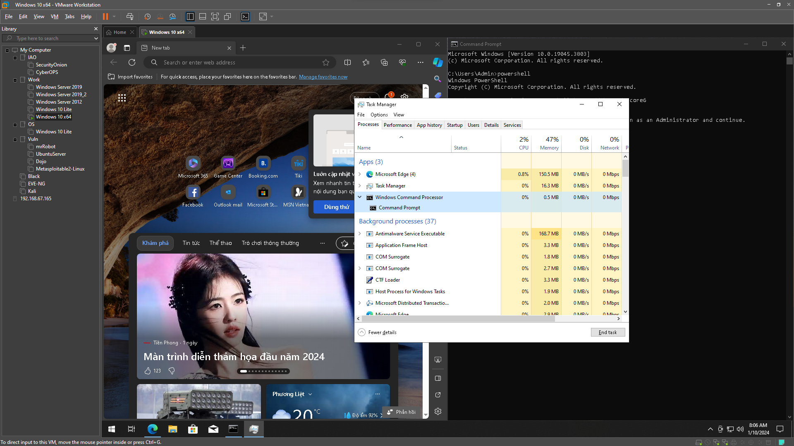

There are three categories of processes listed in the Processes tab: Apps, Background processes, and Windows processes.

Right-click Console Window Host and select **Properties**.

### Question:

What is the location of this filename and location of this process?

C:\Windows\System32

File: conhost.exe

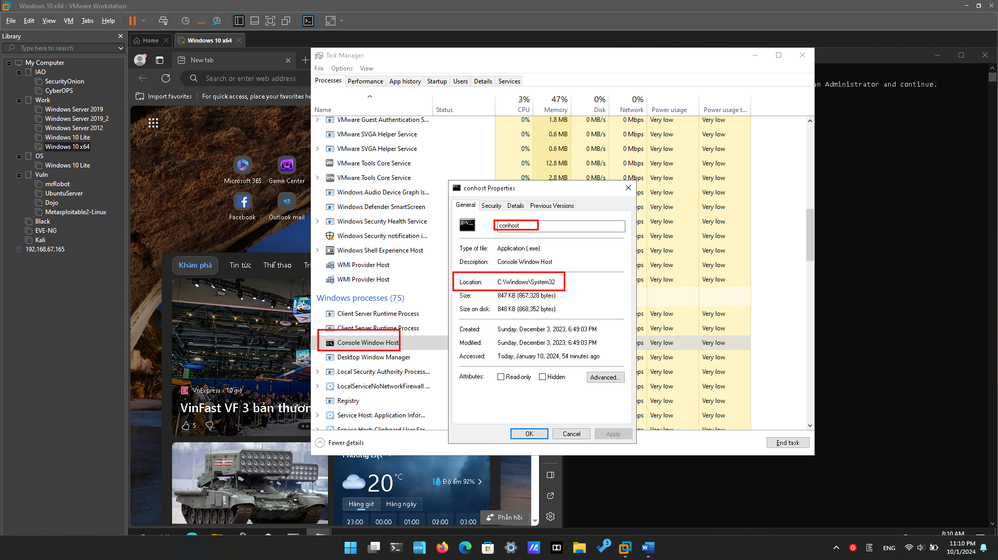

Close the command prompt window.

### Question:

What happens to Windows Command Processor and Console Window Host when the command prompt window is closed?

Windows Command Processor and Console Window Host no longer listed in the Task Manager.

Click the Memory heading. Click the Memory heading a second time.

### Question:

What effect does this have on the columns?

All process will be sorted by the amount of memory each process is using.

Right-click on the Memory heading, and then select **Resource values** > **Memory** > **Percents**.

### Question:

What affect does this have on the Memory column?

It displays memory usage in percentage values.

### Question:

How could this be useful?

Figuring out which services might be contributing to memory problems entails revealing the extent of available memory utilized by individual services.

In the Task Manager, click the **Name** heading.

Double-click the Microsoft Edge.

### Question:

What happens?

It will display all sub-process of the Microsoft Edge.

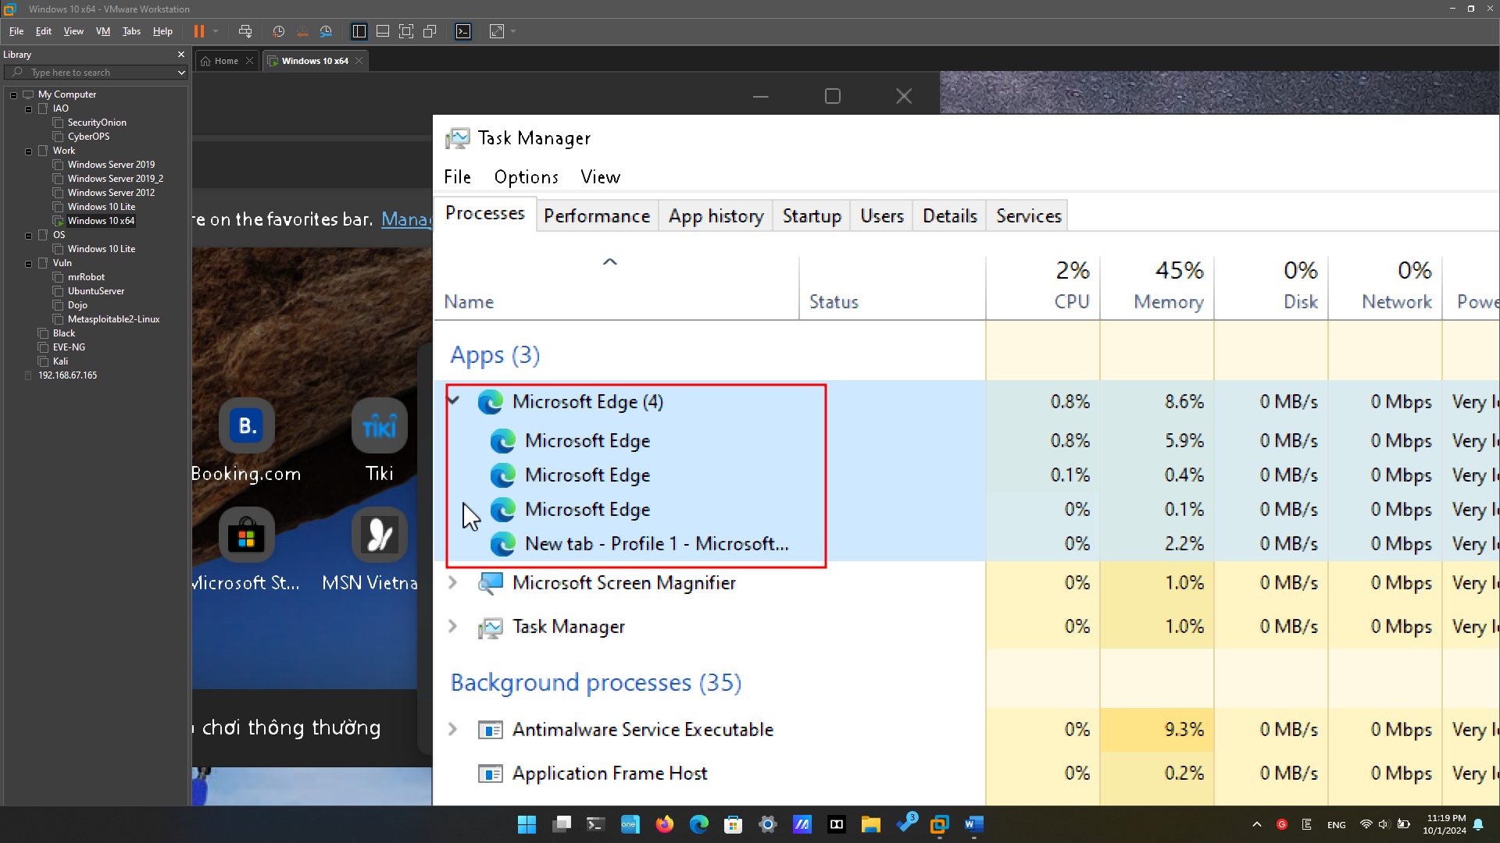

Return to the Task Manager and right-click Microsoft Edge. Select **End task**.

### Question:

What happens to the web browser windows?

The web browser windows ended and closed.

## Working in the Services tab

In the Task Manager window, click the **Services** tab. Use the scroll bar on the right side of the **Services** window to view all the services listed.

### Question:

What statuses are listed?

Stopped and Running

## Working in the Performance tab

In the Task Manager window, click the **Performance** tab.

### Question:

How many threads are running?

1014 threads

### Question:

How many processes are running?

114 processes.

Click the **Memory** in the left panel of the **Performance** tab.

### Question:

What is the total physical memory (MB)?

4.0 GB

What is the available physical memory (MB)?

2.2 GB

How much physical memory (MB) is being used by the computer?

1.8 GB

Click the **Ethernet Chart** in the left panel of the **Performance** tab.

What is the link speed?

Ethernet - 100 Kbps

What is the IPv4 address of the PC?

192.168.26.142

Click **Open Resource Monitor** to open the Resource Monitor utility from the Performance tab in Task Manager.

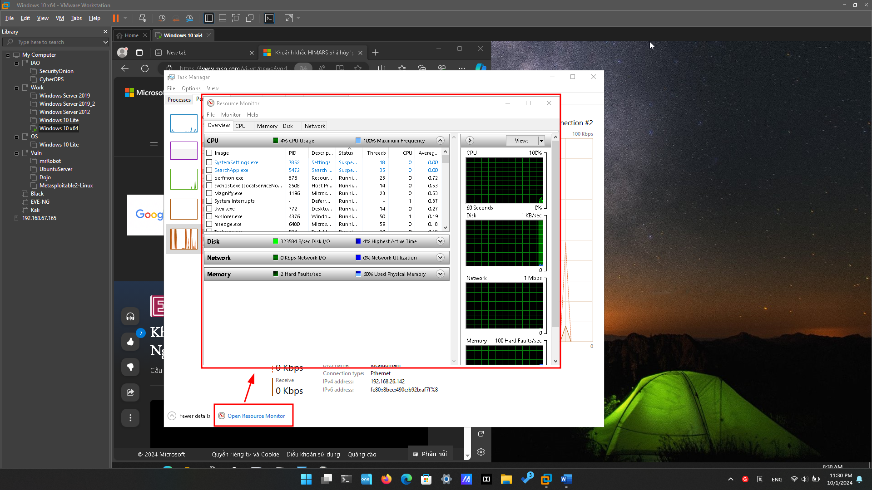

# Reflection Question

1. Why is it important for an administrator to understand how to work within the Task Manager?

Administrators need Task Manager proficiency to monitor system performance, troubleshoot issues, and optimize resource usage for a stable computing environment.